Answering Nietzsche
Perm Solvency 2
Turn: Cross Cultural Exchange 3
ALT Fails 4
Aff Solves K 5
Turn: Alt leads to Genocide 6
Turn: Alt fails 7
Turn: ALT prevents Change 8
Turn: Individual Ontology 9
K fails 10
K Fails 11
Nietzsche Ideology Flawed 12
Turn: Norms Good 13
Turn: Nietzsche Justifies Genocide 14
Alt Fails 15
K fails cannot be politicized 16
Turn: Genocide 17
Turn: Nazism 18
K fails- Contradicts 19
Kritik Fails 20

Perm Solvency

Perm: engage in authoritative action and pass the plan while recreating its values by Rejecting the value to life and recreating the Communities self-consitution. WOrking alone fails.

Bonnie Honig, Professor of Political Science and Senior Research Fellow 1993[“Political Theory and the Displacement of Politics”. Cornell university press]

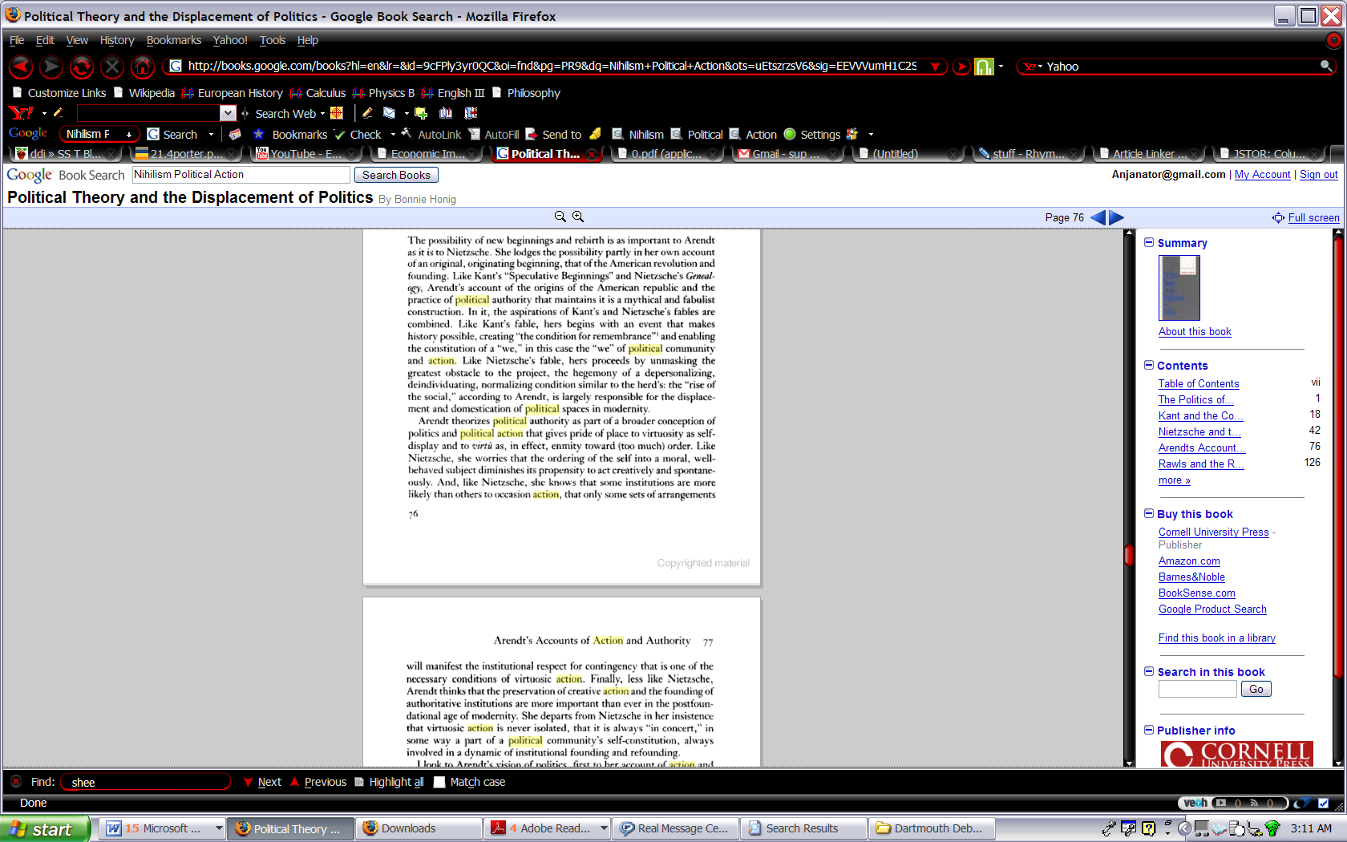

Turn: Cross Cultural Exchange

We need to intervene and help other nations in order to allow for a cross-cultural exchange that allows a bridge between the East and the West to welcome the stranger.

Darrel J. Fasching, Professor of Religious Studies at The university of South Florida, 1993 [“The Ethical challenge of Auschwitz and Hiroshima: Apocalypse or Utopia ?” ]
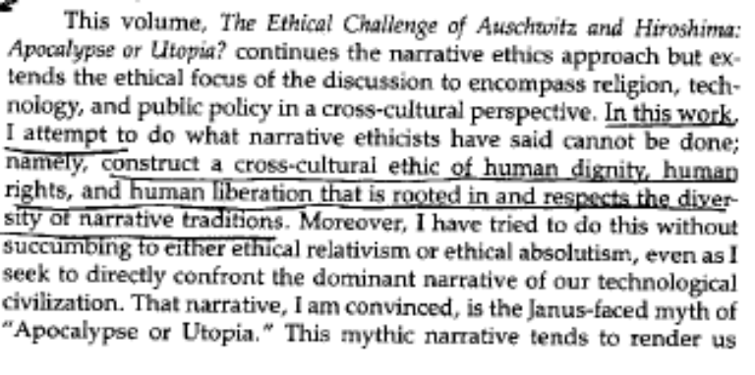

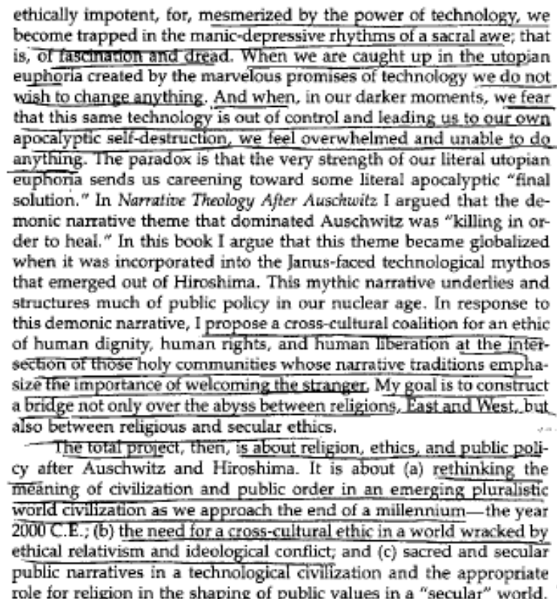

ALT Fails

Critique of culture fails because it is embedded in the culture it criticizes. The affirmative plan that transcends the cultural norms of society is the prerequisite to any criticism.

Darrel J. Fasching, Professor of Religious Studies at The university of South Florida, 1993 [“The Ethical challenge of Auschwitz and Hiroshima: Apocalypse or Utopia ?” ]

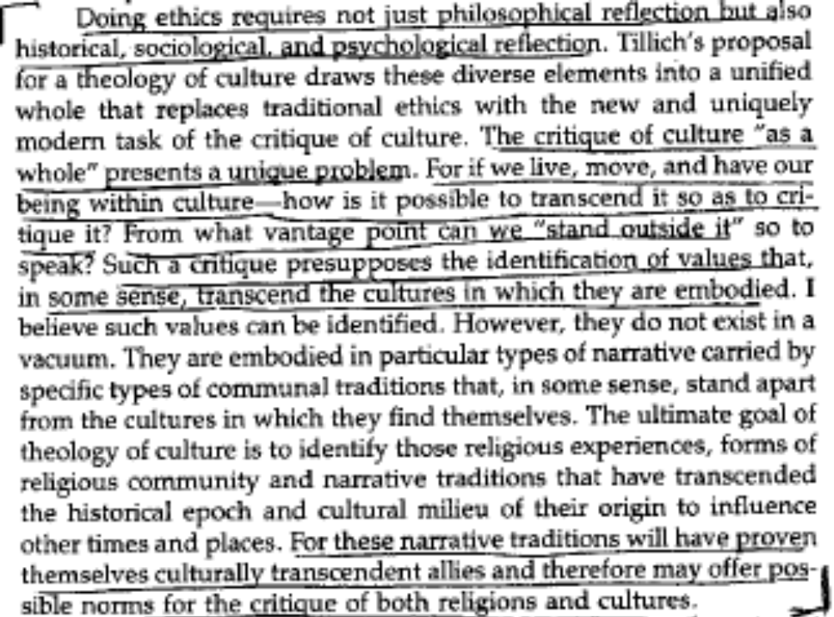

Aff Solves K

Our affirmative plan expands our horizons to the other in Africa creating possibilities for what can be done, expanding on what is held to be true instead of rejecting it completely.

Darrel J. Fasching, Professor of Religious Studies at The university of South Florida, 1993 [“The Ethical challenge of Auschwitz and Hiroshima: Apocalypse or Utopia ?” ]

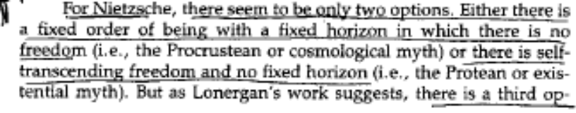
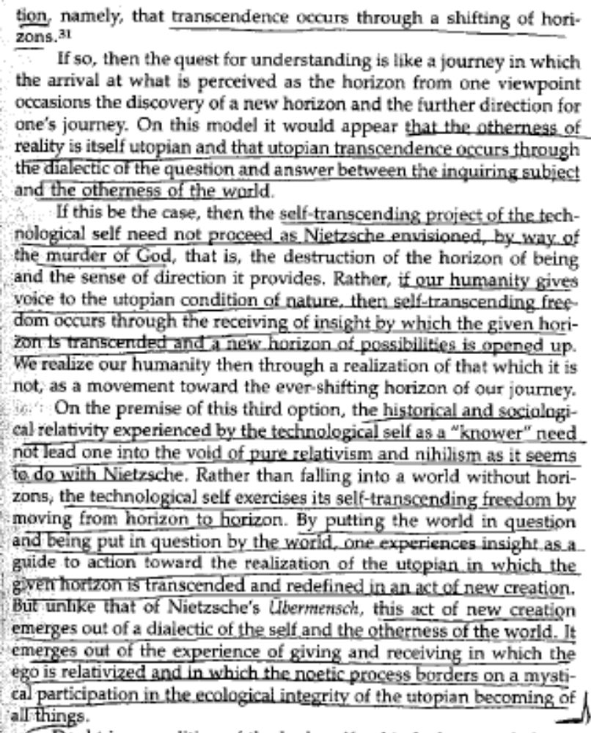

Turn: Alt leads to Genocide

Nietzsche’s rejection of societal norms results in perpetual self destruction. A normative view of society is required to prevent unrestrained use of technology and an extermination of populations.

Darrel J. Fasching, Professor of Religious Studies at The university of South Florida, 1993 [“The Ethical challenge of Auschwitz and Hiroshima: Apocalypse or Utopia ?” ]

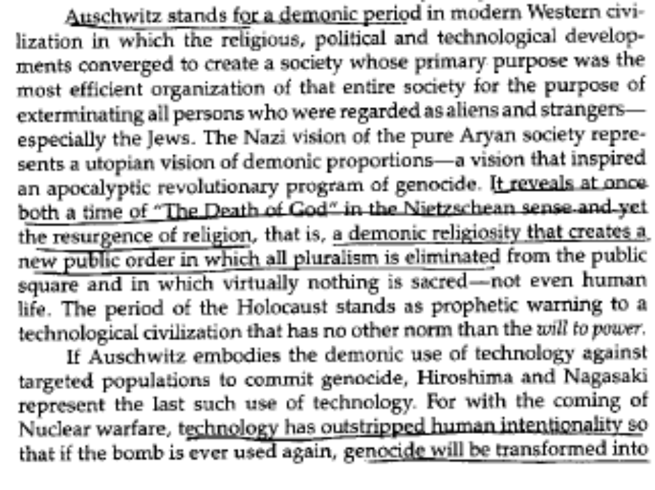

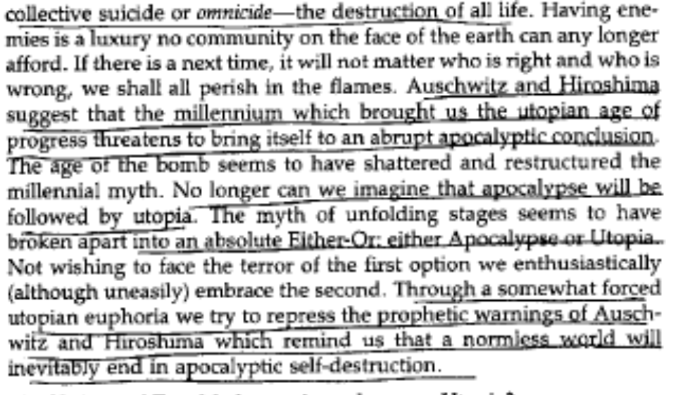

Turn: Alt fails

Utopian Alternatives like the Criticism are inevitable lead to an apocalyptic Solution

Darrel J. Fasching, Professor of Religious Studies at The university of South Florida, 1993 [“The Ethical challenge of Auschwitz and Hiroshima: Apocalypse or Utopia ?” ]

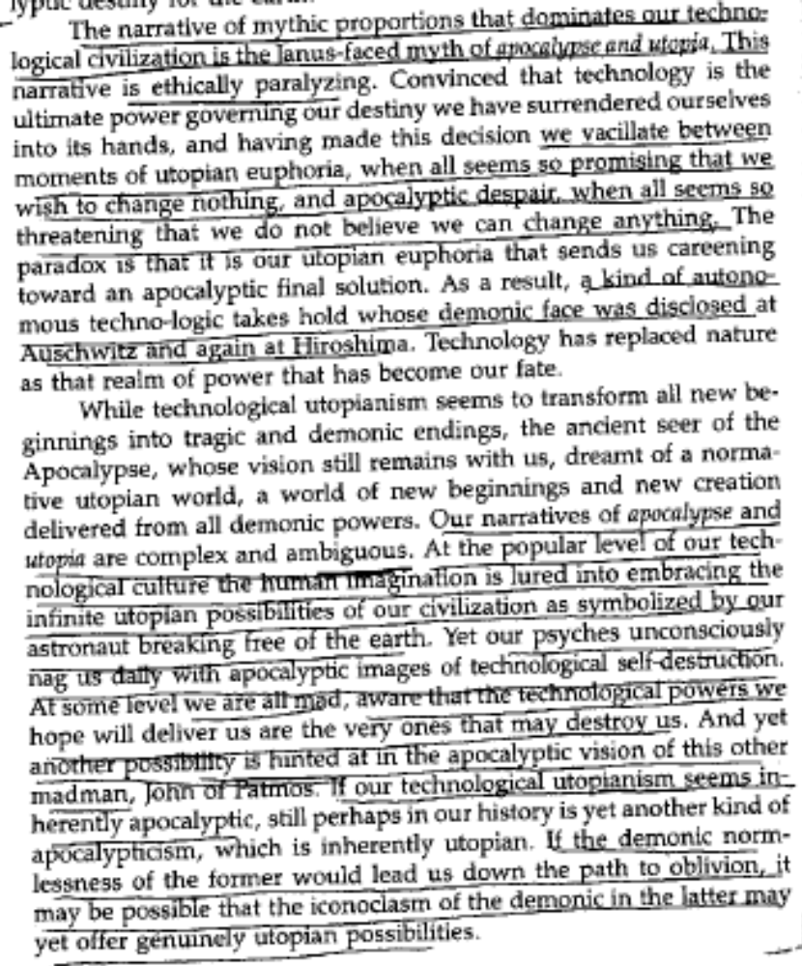

Turn: ALT prevents Change

Extreme alternatives or paradigms prevent change from occurring

Darrel J. Fasching, Professor of Religious Studies at The university of South Florida, 1993 [“The Ethical challenge of Auschwitz and Hiroshima: Apocalypse or Utopia ?” ]

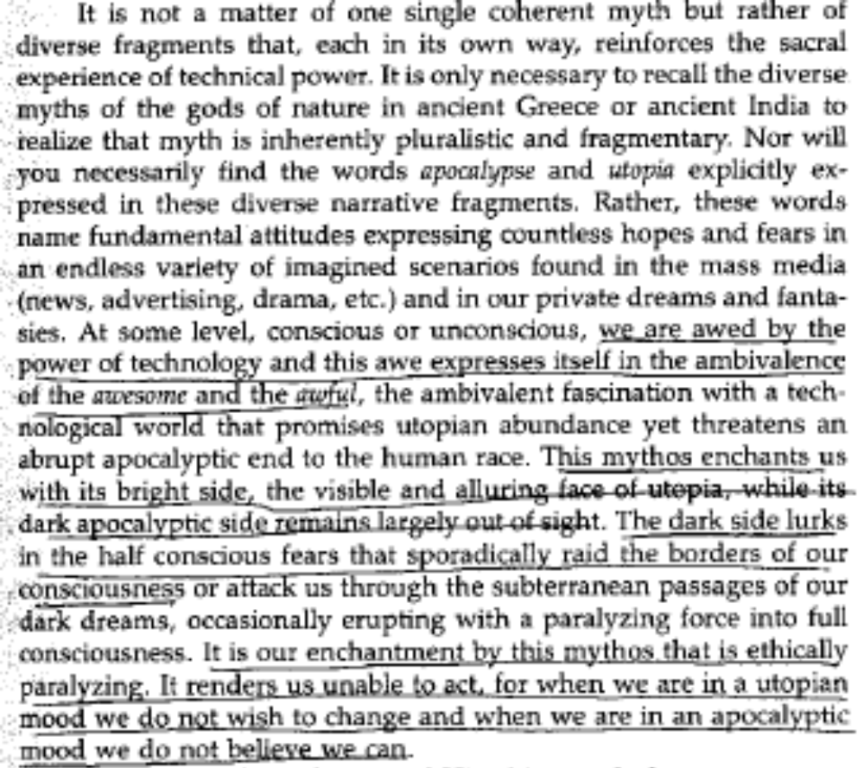

Turn: Individual Ontology

Human exploration and understanding the world is an attempt to change an realize ontology.

Darrel J. Fasching, Professor of Religious Studies at The university of South Florida, 1993 [“The Ethical challenge of Auschwitz and Hiroshima: Apocalypse or Utopia ?” ]

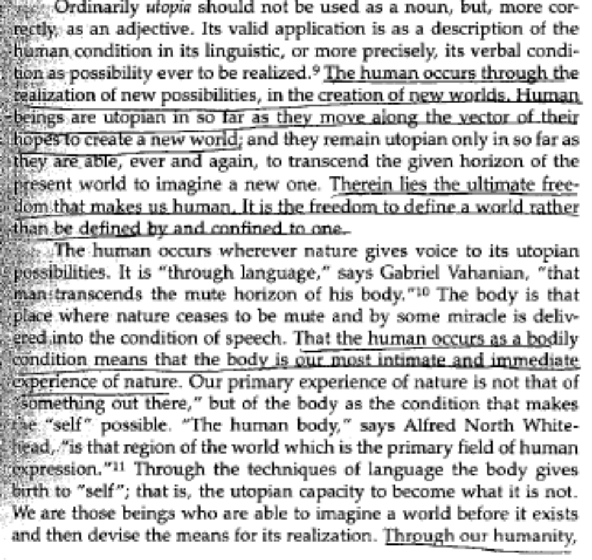

K fails

The Fact that Nietzsche’s definition of superman precludes any public discussion of his change meaning that in order for the alternative to function, it cannot be brought into political dialogue.

Darrel J. Fasching, Professor of Religious Studies at The university of South Florida, 1993 [“The Ethical challenge of Auschwitz and Hiroshima: Apocalypse or Utopia ?” ]

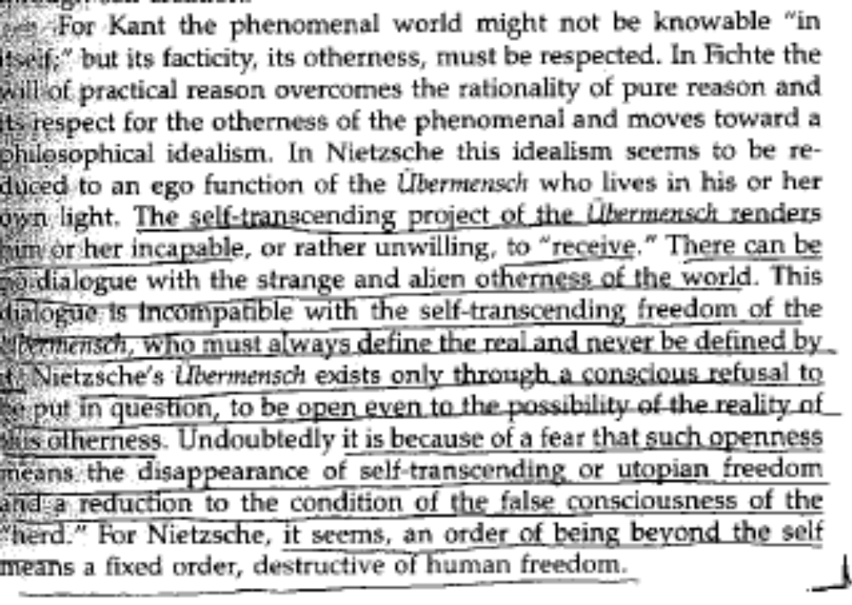

K Fails

We need to engage in action to discover our modes of transcendence and welcome the stranger.

Darrel J. Fasching, Professor of Religious Studies at The university of South Florida, 1993 [“The Ethical challenge of Auschwitz and Hiroshima: Apocalypse or Utopia ?” ]

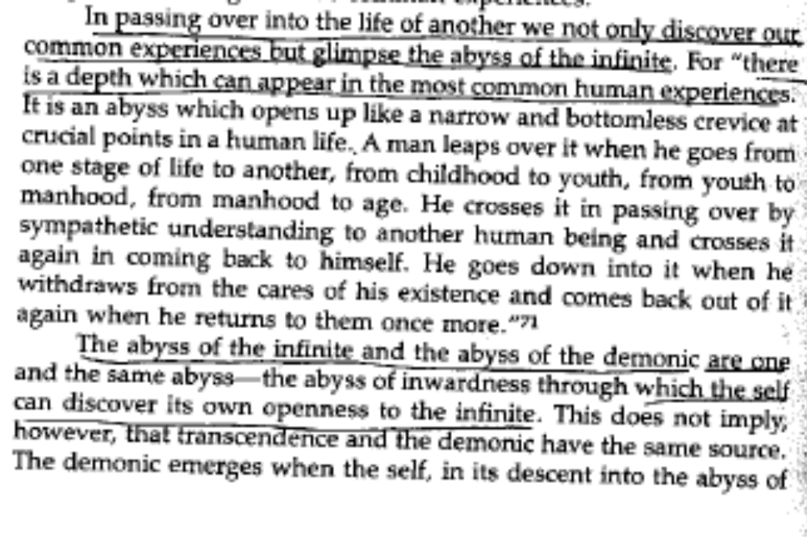

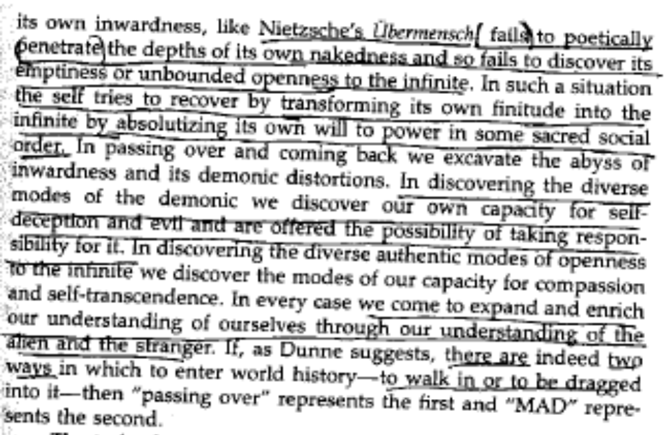

Nietzsche Ideology Flawed

Nietzsche incorrectly assumes that every action is a will to truth to stop chaos. Rather operating under a human rights framework breaks down a mutually assured destruction mentality
Darrel J. Fasching, Professor of Religious Studies at The university of South Florida, 1993 [“The Ethical challenge of Auschwitz and Hiroshima: Apocalypse or Utopia ?” ]

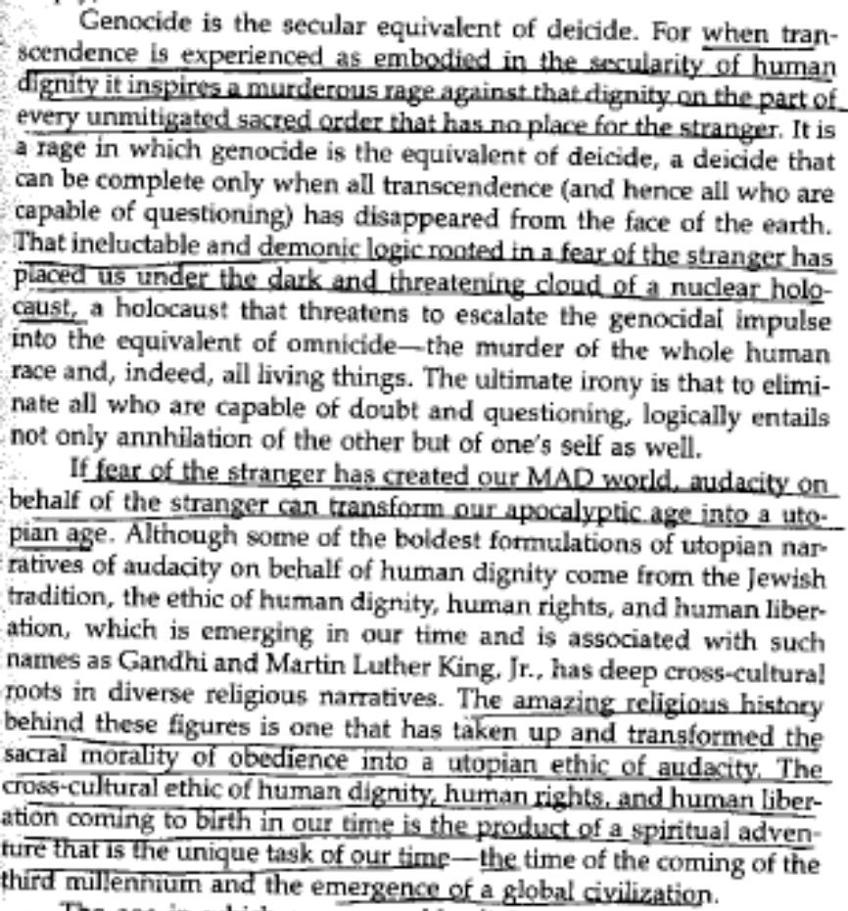

Turn: Norms Good

Nietzsche’s madman envisions a world without horizons, that treats the world as disconnected from the human and systematically destroying it because o of the lack of norms.

Darrel J. Fasching, Professor of Religious Studies at The university of South Florida, 1993 [“The Ethical challenge of Auschwitz and Hiroshima: Apocalypse or Utopia ?” ]
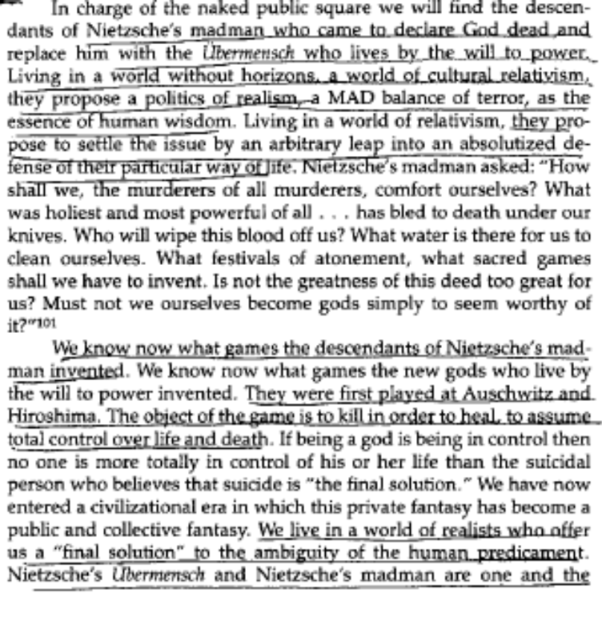
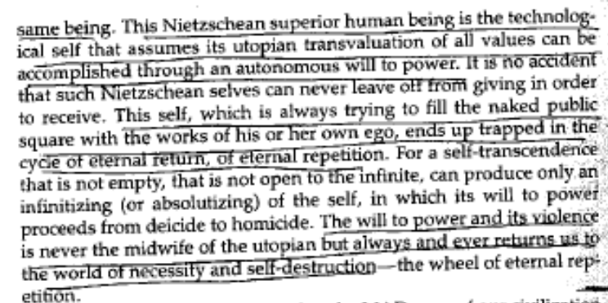

Turn: Nietzsche Justifies Genocide

Nietzsche’s view of the superior being results in endless genocide because it assumes an endless cycle of values that need to be transcended by elite action.

Darrel J. Fasching, Professor of Religious Studies at The university of South Florida, 1993 [“The Ethical challenge of Auschwitz and Hiroshima: Apocalypse or Utopia ?” ]

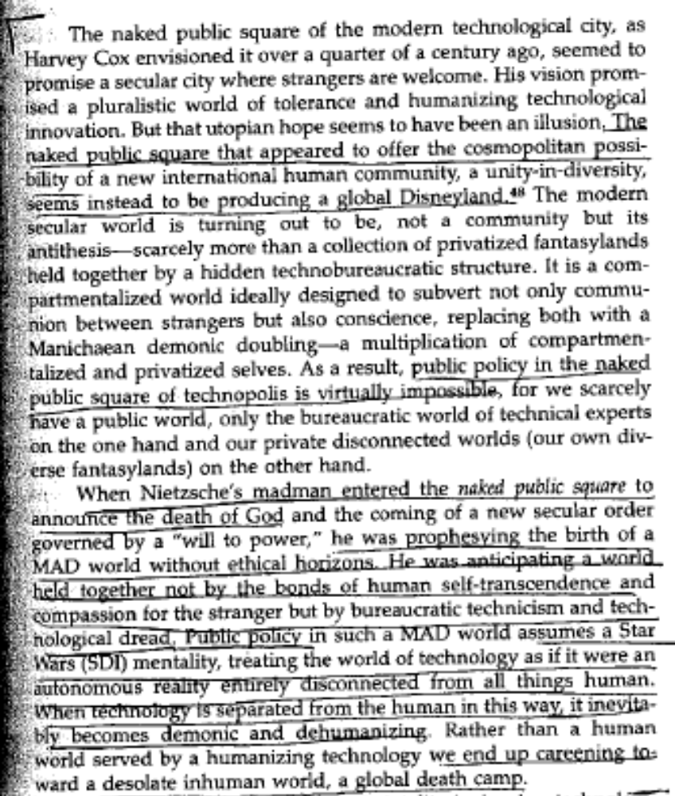

Alt Fails

Nietzsche’s alternatives have almost no action, and they cannot be implemented, because there is no normative vision or distinction between choices.

Steven Conway, philosophy at Penn State, 1992 (http://64.233.161.104/search?q=cache:N7yE-LNZBsoJ:www.subverbis.com/essays/chestertonnietzsche.rtf+nietzsche+ethics+genocide&hl=en)

For all Nietzsche's rallying cries for courageous action to would be masters, little action resulted. Nietzsche's courage was hollow and ineffectual to Chesterton. He compared Nietzsche to Joan of Arc to prove his point.
"Nietzsche only praised the warrior; she was the
warrior...we know she was not afraid of an army,
while Nietzsche, for all we know, was afraid of a
cow" (Chesterton 247).
Where the will was liberating to Nietzsche, Chesterton found freedom in possessing the courage to accept orthodoxy and 'its manifold paradox. Nietzsche's freedom was ephemeral at ,best. Inherent in the concept of will was a desire for self limitation. A choice, once made, was an acceptance of something and a rejection of everything else. "Art is limitation. The essence of every picture is a frame" (Chesterton 243). In essence, freedom had enslaved itself (Chesterton 240). All choices had the same moral weight if Nietzsche was correct in stating that the choice itself was singularly important. Hitler's decision to commit genocide and a decsion to eat a ham sandwich cannot be separated (Chesterton 246). Change itself had become unchangeable; it had become institutionalized and, thus reified in the Marcusian sense of the word.

K fails cannot be politicized

Nietzsche’s criticism fails because it can never be reduced to a political ideology. They fail to entail all of Nietzsche’s ideas.

Jacob Golomb and Robert S. Wistrich, philosophy and Jewish history at Hebrew University in Jerusalem, 7/9/02 (http://www.pupress.princeton.edu/chapters/i7403.html)
Nietzsche's life and thought will never be reducible to a single constituency or political ideology, as this volume makes plain. The ambiguities and contradictions in his work as well as his elusive, aphoristic style lend themselves to a wide range of meanings and a multiplicity of interpretations. Nevertheless, while acknowledging this diversity, the editors cannot in good conscience be exempted from the challenge of offering some guidelines regarding the central issues raised by a book about Nietzsche and fascism, even if the title (as seems appropriate in this case) ends with a question mark.

Turn: Genocide

Nietzsche takes genocide to the extreme by allowing sacrifice of untold numbers of people to be sacrificed. His ideas of political aggression and supremacy only perpetuate the horrors of the 20th century

Jacob Golomb and Robert S. Wistrich, philosophy and Jewish history at Hebrew University in Jerusalem, 7/9/02 (http://www.pupress.princeton.edu/chapters/i7403.html)
Nietzsche was clearly an elitist who believed in the right to rule of a "good and healthy aristocracy," one that would, if necessary, be ready to sacrifice untold numbers of human beings. He sometimes wrote as if nations primarily existed for the sake of producing a few "great men," who could not be expected to show consideration for "normal humanity." Not suprisingly, in the light of the cruel century that has just ended, one is bound to regard such statements with grave misgivings. From Mussolini and Hitler to Stalin, Mao, Pol Pot, and Saddam Hussein, the last eighty years have been riddled with so-called political geniuses imagining that they were "beyond good and evil" and free of any moral constraints. One has to ask if there is not something in Nietzsche's philosophy with its uninhibited cultivation of a heroic individualism and the will to power, which may have tended to favor the fascist ethos. Musssolini, for example, raised the Nietzschean formulation "live dangerously" (vivi pericolosamente) to the status of a fascist slogan. His reading of Nietzsche was one factor in converting him from Marxism to a philosophy of sacrifice and warlike deeds in defense of the fatherland. In this mutation, Mussolini was preceded by Gabriele d'Annunzio, whose passage from aestheticism to the political activism of a new, more virile and warlike age, was (as Mario Sznajder points out in his essay) greatly influenced by Nietzsche. Equally, there were other representatives of the First World War generation, like the radical German nationalist writer, Ernst Jünger, who would find in Nietzsche's writings a legitimization of the warrior ethos (as David Ohana makes clear). There have also been Marxist critics like George Lukács, who saw in Nietzsche's philosophy nothing more than an ideological apologia for the rapacious plunder of German capitalist imperialism and a particularly destructive form of irrationalism. Lukács insisted both on the reactionary coherence of Nietzsche's "system" and on the "barren chaos" of his arbitrary language, singling him out as one of the most dangerous "intellectual class-enemies" of socialism. Lukács's own miserable record as an apologist (for the crimes of Stalinism), gave his one-sided reading of Nietzsche (which equated hostility to egalitarian socialism with fascist imperialism) transparently propagandist coloring, yet it is an interpretation that had considerable influence in its day.

Turn: Nazism

Nietzsche’s philosophies justify annihilation. This ethic has been masked by other writers, but in essence, Mein Kampf was an outgrowth of Nietzschean thought.
Michael Kalish, PhD student in philosophy at UC Santa Barbara, 2004 (http://www.history.ucsb.edu/faculty/marcuse/classes/133p/133p04papers/MKalishNietzNazi046.htm
This proposal of annihilation highly compares to Hitler's policies of extermination. Both Hitler and Nietzsche assert that the host of the slavish disease of values and decay is the clever Jew, the need for a spiritual base of independence of thought and action, the revaluation of strong and weak, and the annihilation of the slaves. By juxtaposing Hitler's work and Nietzsche's, the groundwork of Mein Kampf is clearly a literal interpretation of Nietzsche's work.
The underlying themes in Nietzsche and Hitler's philosophies are the importance of impulses and action for self-preservation, the danger of the clever Jew (i.e. the slave who has re-valuated strong as evil and weak as good), and the prophesy of a new type of man that will question the Jewish values and return the glory of the blond beast. Although Nietzsche's reference to slaves and masters are references to personified moralities, the themes and language are strikingly consistent with the language and terminology used by Hitler in Mein Kampf. Nietzsche's close relationship with Richard Wagner, Elisabeth's reconciliation of Nietzsche's work with Wagner's racist ideology, and Hitler's praise of Wagner's work suggests that Hitler may have read Nietzsche's work. Elisabeth's political involvement with the Nazis, and Hitler's multiple visits to the Nietzsche archive suggest Hitler's direct awareness and interest in Nietzsche's philosophy. And finally, the radical content and similar terminology used by the Nietzsche and Hitler implies that Nietzsche's influence in 20th century Germany may have extended to the Führer, as a narcissistic discovery of the Superman. In the conclusion of Mein Kampf Hitler wrote (Hitler, 688):
A state which in this age of racial poisoning dedicates itself to the care of its best racial elements must some day become lord of the earth. May the adherents of our movement never forget this if ever the magnitude of the sacrifices should beguile them to an anxious comparison with the possible results.

K fails- Contradicts

Nietzsche contradicts himself by making value judgements that are forbidden by his relativism showing the inevitability of these values and truths and the improbability of the Kritik.

Joseph E. Steineger, Quodlibet Journal: Volume 6 Number 1, January - March 2004 [The Failure of Friedrich Nietzsche and Sigmund Freud’s Objection to Thomistic (Objective) “Truth” and “Right”]

Despite Nietzsche’s argument for the Superman as the ideal illustration of man, he contradicts himself in asserting that value may not be assigned by men in the world: “One would have to be situated outside of life…to be permitted to touch on the problem of the value of life at all: sufficient reason for understanding that this problem is for us an inaccessible problem.” It is not possible for Nietzsche to hold this “inaccessibility” view and his notions of the “Will to Power,” the “Superman,” or any assertion that places value on a certain way of life over another. Nietzsche does not recognize his contradiction in asserting there is no possibility of discerning objective value in life, yet stating that Christianity’s emphasis on charity and suffering makes an individual “weak,” thereby agitating that individual’s innate Will to Power and making him “sick.” This inherently assumes that sickness is bad, weakness is bad, and power is good; all of which are value judgments forbidden by relativist presuppositions.

Kritik Fails

Values are a prerequisite to joy meaning that Nietzsche’s desire to embrace joy is impossible under his framework.

Jonathan Wymore, Truth and Value: the Philosophy of Dietrich von Hildenbrand Volume V, 1992 [article “Nietzsche, Von Hildebrand, and Human fulfillment”]

The direction my criticism takes is that Nietzsche's denial of any value significance outside the person-who-wills makes it impossible, strictly on the basis of the denial, to have an affective life containing joy, gratitude, awe, reverence, admiration, and the like - affects essential to fulfilled, happy human existence. And, in fact, should one succeed in seeing the world as meaning-neutral, or devoid of value, one would have by that very fact emptied life of the significance necessary to ground affective experiences such as awe or esteem.
In order to develop my criticism of Nietzsche, that a Nietzschean view of value would empty the world of the meaning necessary by which a full and affective life is possible, I want to draw upon Dietrich von Hildebrand's insight into "categories of importance" developed especially in his Ethics. Von Hildebrand there elucidates three "categories of importance"*: the category of the "important-in-itself," that is, the intrinsically valuable or precious; that of the "subjectively satisfying"; and that of the importance of the "objective good for the person." (1) The important-in-itself is that which ought to exist because of its intrinsic worth, such as the preferring of truth over error. (2) That which derives its importance because it pleases us makes up the category of the subjectively satisfying. (3) Air, shelter, food, and medicine are all important as objective goods for the person. They act beneficently for and upon man. All these "moments" of importance draw things out of neutrality. They are the motivation by which things take on interest for us. Love may emerge from neutrality, significant, because it is pleasurable to me; hence it is subjectively satisfying. Or it may emerge from neutrality because love produces truly beneficial elements in persons; hence, it is an objective good for the person. Or, finally, one can have insight into the essence of love itself and see it to be entirely precious in virtue of its immanent nature. Love emerges from neutrality and is significant, above all else, because of its own essence - not because it does something beneficial or because it brings about my pleasure, but because of what it is in itself. It is good that love qua love exist rather than not exist. It is precious in and of itself, and its existence adds a priceless treasure to living.
Nietzsche completely denies the category of importance that we term the important-in-itself, or the intrinsically valuable. He claims that objective reality is value-neutral. In Nietzsche's mind there is nothing intrinsically precious which can, of its own nature or act, be the reason for its being lifted out of neutrality. Value is never discovered; it is only created. Hence, we enter at birth into a world which has no pre-given meaning, and it is up to the individual to create significance by a fiat of the will.
It is on the basis of this denial of the important-in-itself that a completely Nietzschean view would render a fully human life impossible - insofar as life is experienced strictly along the lines Nietzsche declares. This is because human life in order to be full and vital depends upon the experience of things which have the power, that is, the sufficient weight and grandeur of being, capable of eliciting responses such as we have mentioned. Gratitude, deep joy, reverence, humility, awe, admiration, and love come about from our contacts with values for which we can be grateful, about which we can feel joy, before which we can experience reverence, humility, awe, or admiration, or to which we may give ourselves in love. All these affective states presuppose conscious objects of knowedge, prior to any act of the will, to which we respond or by which we are moved. For instance, we respond with admiration to great honesty or courage, or with thanksgiving for a precious gift, or with appreciation and gratitude to the loyalty of a friend. We respond to these things in the way that we do because of the knowledge of their significance, the experience of their ontological and qualitative weight, especially to their intrinsic beauty. According to von Hildebrand: "there exist certain affective responses which are essentially value responses, that is, are motivated only by values. Such, for instance, are esteem, veneration, and admiration" (Ethics, p. 211). Nietzsche seems to miss entirely the fact that a joyful life depends upon the existence of intrinsically precious objects and qualities which are capable of engendering our response of joy. Von Hildebrand wrote: "those things endowed with value possess a capacity of bestowing delight" (p. 36). What Nietzsche fails to note is that joy and thanksgiving, as well as many other feelings consciously related to their objects, do not arise from knowing objects or acts which are, in themselves, value-neutral. The world, insofar as it is perceived as value-neutral, could only engender negligence, boredom, and indifference. It is precisely because of this that a man blinded to objective value, holding a thoroughly Nietzschean outlook cannot by that very fact experience the preciousness and goodness of life. All external reality, in itself, is neutral for him. The Nietzschean man necessarily lives in a world, that in terms of significance, is dull and flat - because all objectivities are equally neutral in his eyes. Prior to the Nietzschean fiat by which anything meaningful exists, nothing has meaning; and in this context the only due responses are ones such as we have said, negligence, boredom, and indifference.

*

